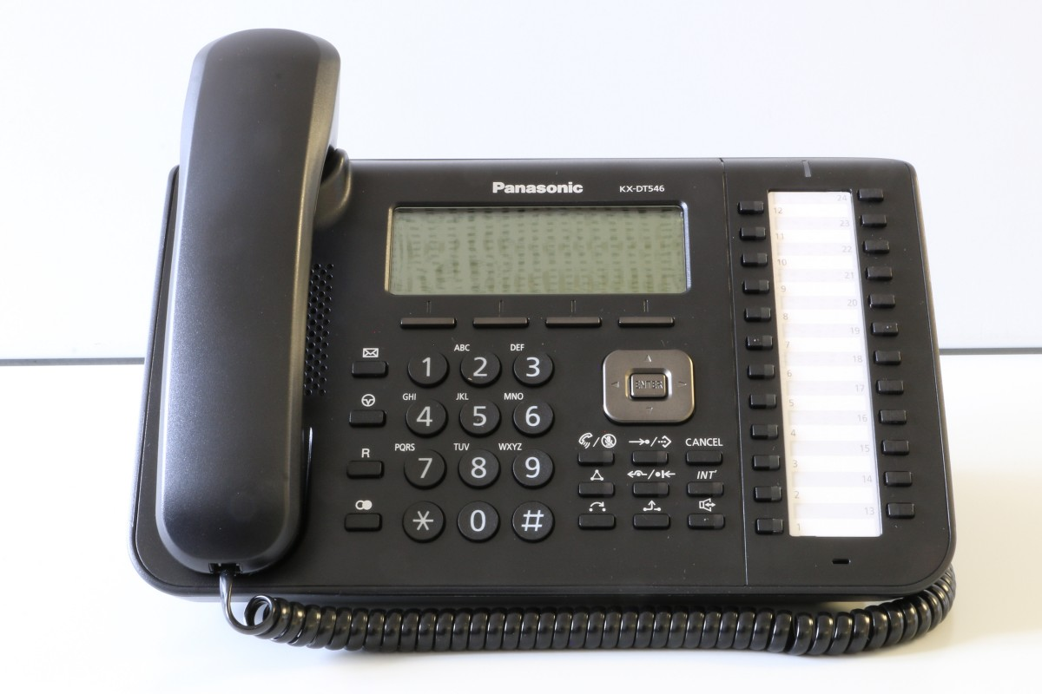
Town of Schleswig
New Phone System
920-894-2483
The Town of Schleswig recently implemented a new telephone system. Effective immediately, please use the phone number above to contact the Town. Leave your name, phone number and a detailed message so that the proper Town Official can return your call.

